This scorecard is produced to provide easier visibility on performance progress across watsonx.
As a reminder, the watsonx rollup is made up of the following offerings across Data platform, Automation and Z TPS portfolios:
- watsonx orchestrate (watsonx assistant, watson discovery, watson API’s)
- watsonx.ai
- watsonx.governance
- watsonx.data
- watsonx code Assistant Enterprise
- watsonx code assistant for Ansible
- watsonx code assistant for Z
- watsonx assistant for Z
- Concert

While our targets for Q2 are bold for both transactional & SaaS, there is no better team to deliver than OURS. We are aligned on five goals to showcase week to week progress and performance in our business:

- Goal 1: Deliver new OI at 3x the current rate of qualified opportunity identification – “does my market have 4x or greater qualified pipe for current quarter and next quarter?”
- Goal 2: 4x the volume of technical engagement to qualify technical wins & accelerate proposal delivery – “will the rate and pace of client & technical engagement enable me to achieve the market objective?”
- Goal 3: Reduce the average time to technical sign off by 75% - “how can we accelerate technical engagement cycles through workshops, custom demos, hackathons and more to increase capacity to do more technical engagement?”
- Goal 4: Drive sales and technical sales OI participation rates to 100% per quarter - “is everyone in the market proactively prospecting?”
- Goal 5: Drive sales productivity participation rates to 75% across transactional & SaaS ACV (i.e. minimum of 75% of sellers have opportunities in call every quarter). - “is everyone in my market on the board? Do we have consistent contribution across territories, managers, brands, etc?”

Moving forward, we will update the scorecard weekly. Today, we start with our Q2 position. Next week, you will see week to week progress metrics across pipeline, productivity and technical activities. Healthy competition across markets

Table 1: Condensed Pipeline Analysis showcasing CQ + NQ pipeline metrics across transactional and SaaS. The product makeup is also included, to showcase where the market may be overachieving in one area vs. another. The data below is from EPM pipeline reports.
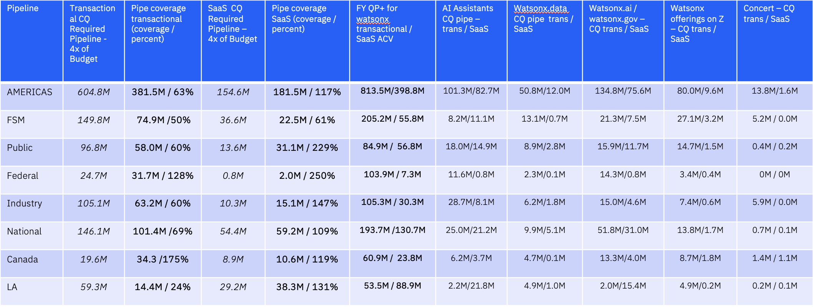
- Currently at 381M of transactional pipe for Americas against a target of 605M (added only 7M of transactional pipe wtw total). We need to build and load pipe aggressively for the next 2 weeks before shifting majority of focus to current quarter progression on transactional. Congrats to Federal and Canada for coming out strong on CQ transactional pipe build for watsonx.
- For SaaS we are in a different spot – we are relatively well covered for SaaS, but historical data showcases we need to spend more time on blocking / tackling and progression for SaaS opportunities. We will begin twice weekly deal huddles on top SaaS opportunities + partner focused deal huddles for National / LA / Canada / to improve penetration in the select segment for progression. Great job to nearly every market for punching above the weight class on SaaS pipeline!
- Note that at week 4, we will adapt the tables above to focus on NQ pipeline to ensure we remain consistent on exercising the business development and pipe build muscles across our teams.
Table 2: Seller Productivity. You’ll find a discreet view across both transactional & SaaS, as well as managers who have greater than 50% of their population with no call. Our focus here is on everyone contributing – there are markets where you are bound to have greater success in SaaS and others in transactional based on current certs, etc. When each seller has points on the board, we become less reliant on larger transactions and skill development of our seller population naturally improves. Let’s focus on every seller having points on the board – transactional or SaaS! This data comes from the seller productivity dashboard in ISC.
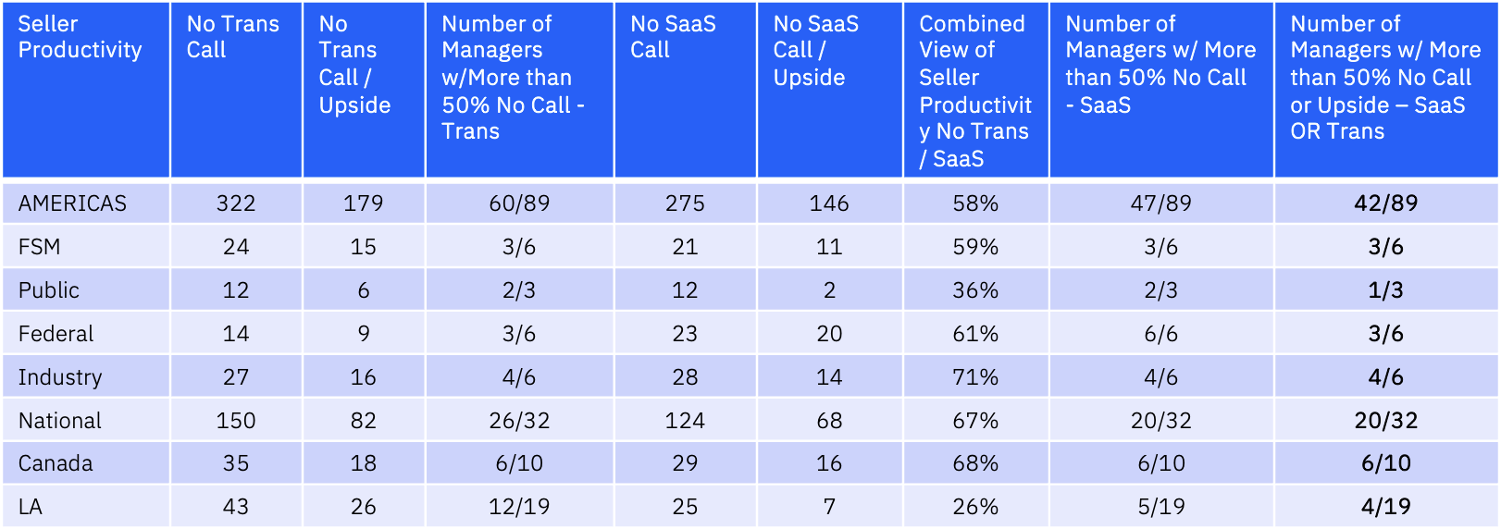
- Please tune into the last column in the above table – this is looking holistically across SaaS / Trans and evaluating managers who have greater than 50% of their teams with no points on the board from a call or upside perspective. We need to ensure these managers have the right level of focus on ensuring contribution across all territories and with all sellers.
- Where we have a lack of CQ productivity, we should see a strong relationship in developing pipeline across these territories. According to CQ and NQ pipeline data, this is not occurring at the rate / pace it needs to for watsonx.
- Our collective goal is 75% seller contribution across the Americas – lets work to have at least 10 more managers that have sellers with ‘points on the board’ by next Monday.

Table 3: Technical Activities. Our volume of technical engagement must increase – the market has moved on from 6 week pilots to condensed technical engagements focused on value at the forefront. We are looking across technical activities in the markets for demos, workshops, business value assessments, architecture engagements and pilots to assess our scope of technical engagement week to week for current quarter opportunities across watsonx offerings. These come from the Technical Sales Dashboard in ISC
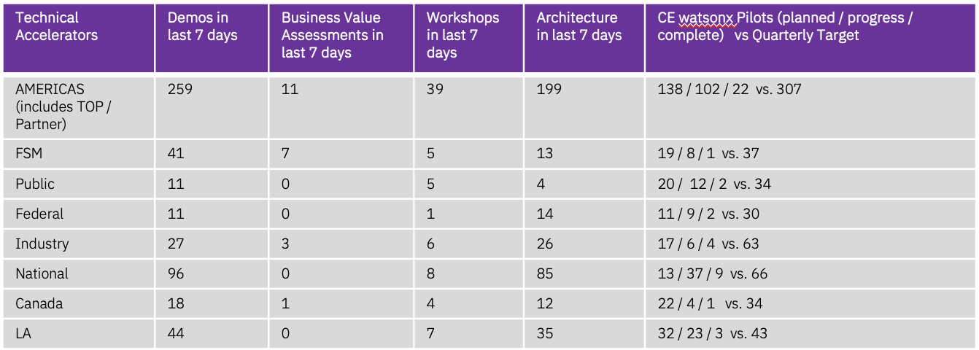
After a deep dive analysis through specific market data in the Technical Sales dashboard, we recognized multiple technical sellers applying the same technical activities across the exact same opportunities. This artificially inflates our level of client engagement + should not be happening given the deep technical specialization & client alignment established for 2025.
Please work with your teams to ensure appropriate coverage & level of technical engagement is occurring. The five categories above are aligned with WW & across markets for where the technical community has been asked to align technical engagement around.

Resources
Americas & Market SME’s, our Technical Teams and more have been hard at work to provide support across pipeline generation & progression activities. We will include new assets, announcements & best practices for your teams to review moving forward.
Please review the full operating plan deck here:
https://ibm.box.com/s/vqv8cw5ddsvf2qm52vrrn5t7uz0v2s1r

Consistent development and rollout of prospecting & business development content
- Golden Sales Playbooks (GSP’s)
    - In production today: HR, Customer Care, AI Governance, Procurement
    - Up Next: Supply Chain, Enterprise Performance Management, Sales Productivity delivered by April 30th
  - Value Creation Frameworks (Aligned to GSP use cases) delivered to all use cases above by May 1
    - Check out the existing value creation frameworks in HR, Customer Care & AI Governance within the GSP
Client Zero Demo Acceleration
  - What: Americas top created a demo tenant whereby client zero use cases are pre-built for sellers to use on the fly (no connection to external endpoints / removes requirement to pre-spin up a techzone instance
  - Demo tenants can serve as the ‘starter kit’ for further customization of client demos (amortizing significant portion of workload up front for custom demos)
  - Goal is to expose the “live chat” environment to customers in the future and these assets will be used to push these into the product faster than they otherwise could be
  - Documentation / Optimal Scripts are built for use cases across the client zero demo environment
  - Client Zero Demo Environment Live Chat: https://ibm.biz/CZDemos
Client Zero Demo Instructions: https://ibm.biz/CZDemoInstructions
Agentic AI 1-2 day bootcamps led by CE
Weekly Wednesday Prospecting Blitzes (30 min activation + 60 minutes pure reach out) – Happening all throughout April

